**Panvalet tips**

**Start P;**

**LANG TYPE :**

**$COPY -** Copybooks

**COBOLMVS** – cOBOL cODE

**$JCL** - jcl LANGUAGE

**$JCLO** – oNE TIME jcl

**Copy Code to panvalet**

**start P;** **3(**UTILITY**);**

**Copy member of Panvalet library n same library**

**2** - CA Panvalet Member Manipulation

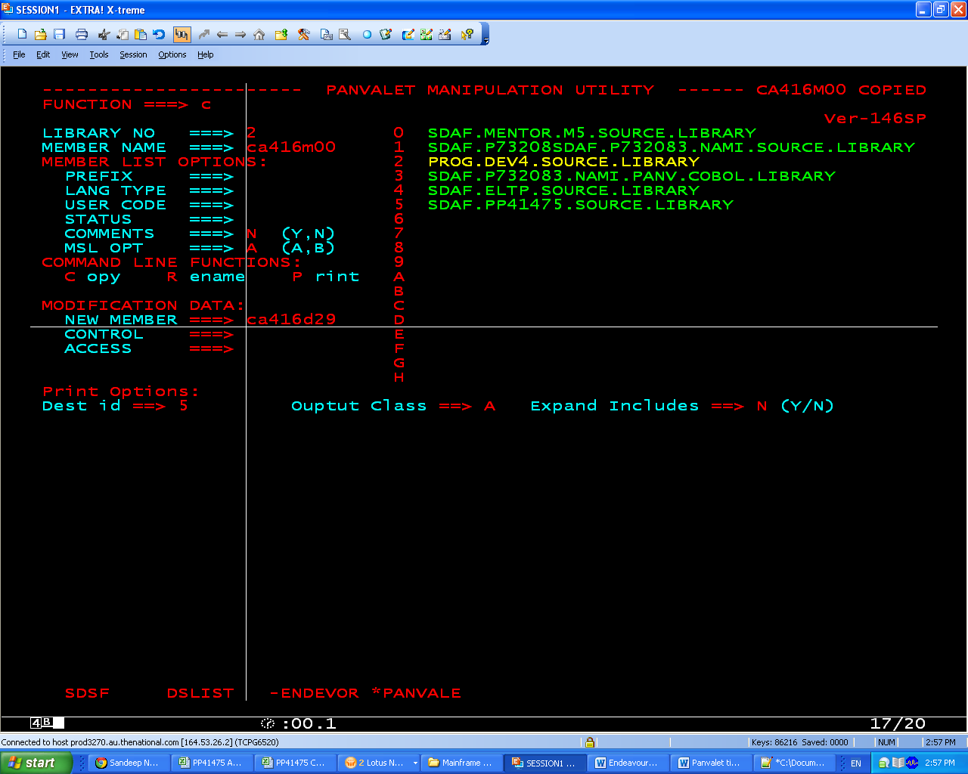

**Copy member of Panvalet library into another panvalet library**

**3.4** –(CA Panvalet Member Library-To-Library Copy)

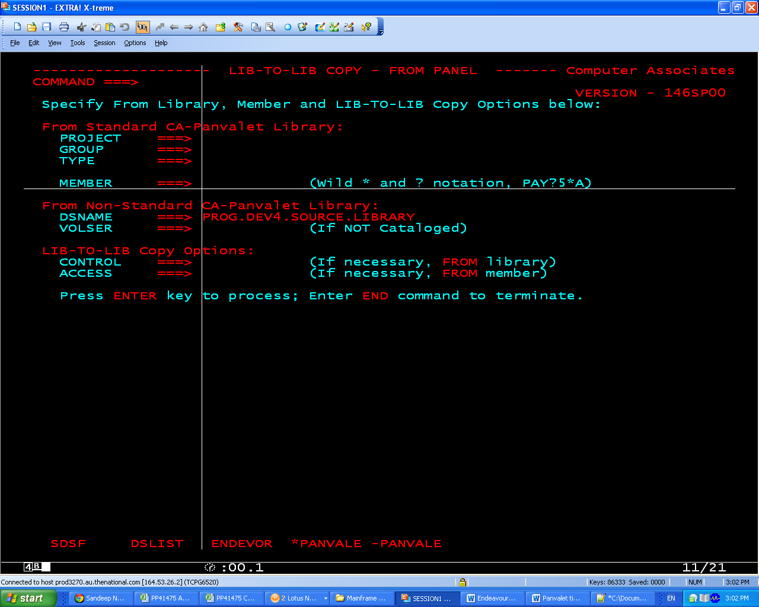

**Destination directory**

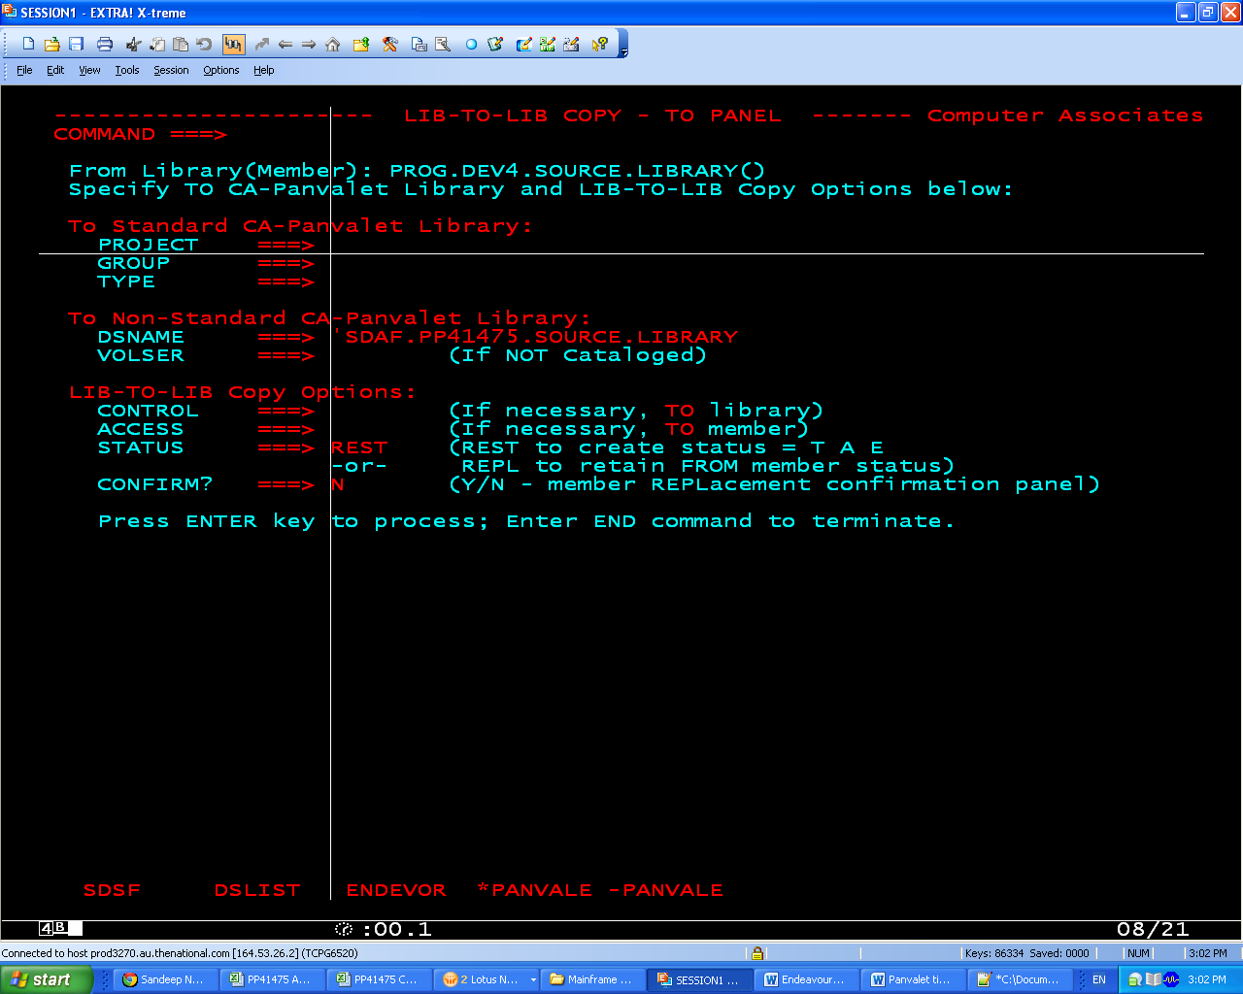

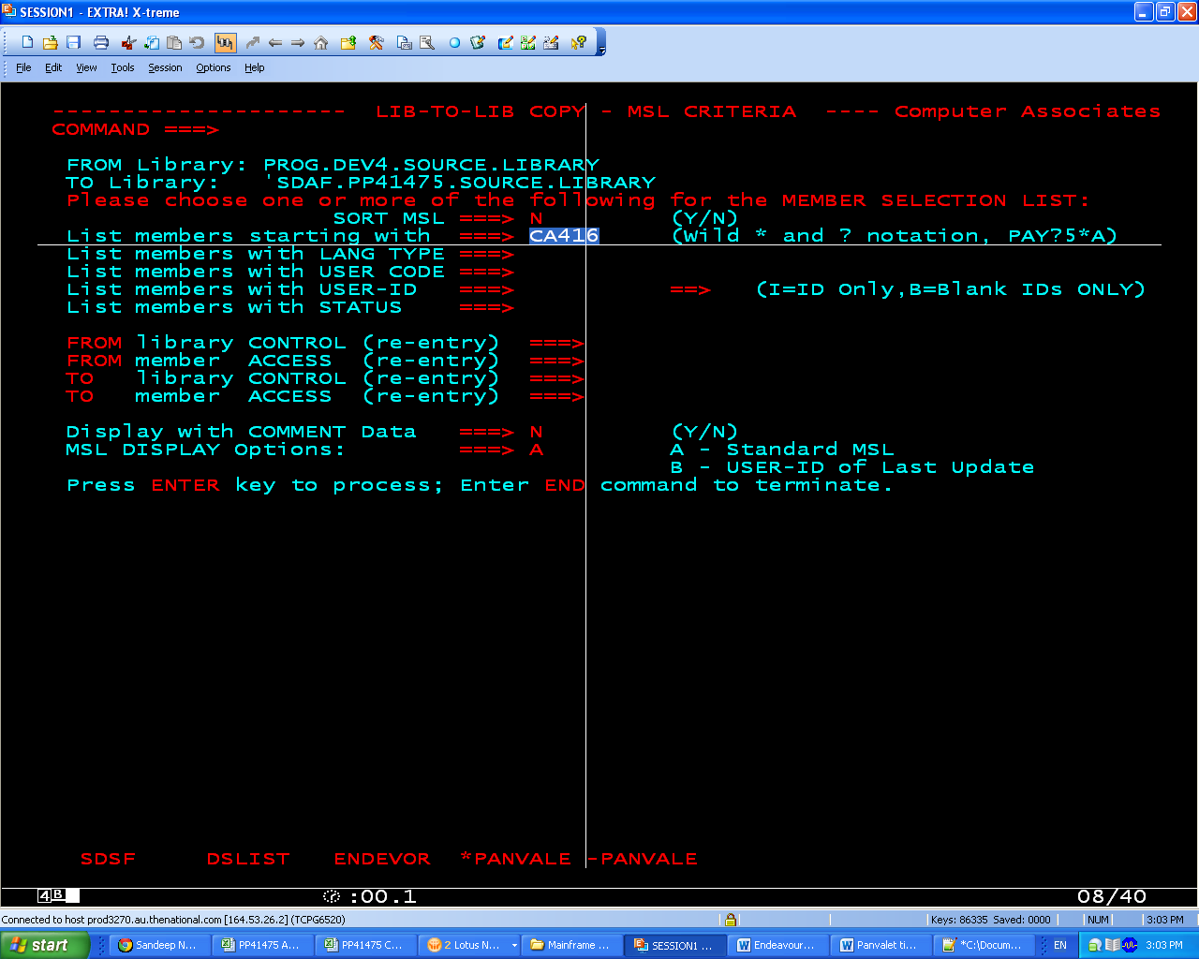

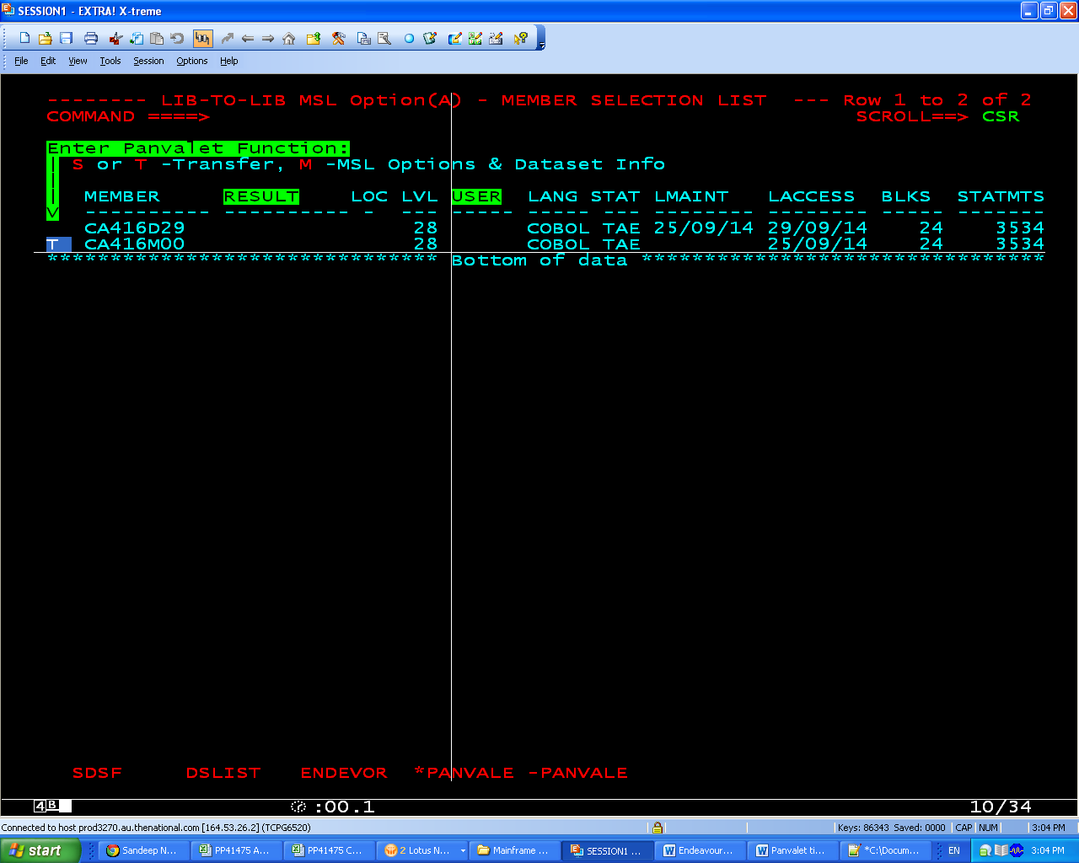

**Copy member of Panvalet library into another Non Panvalet/ PDS library**

**Option 2 -** (Edit) cut and paste the code in the pds